HES Work order containing in two parts first “Raiser” by Station user end and second “Submission” by Fleet end.

**Part – I: Raiser**

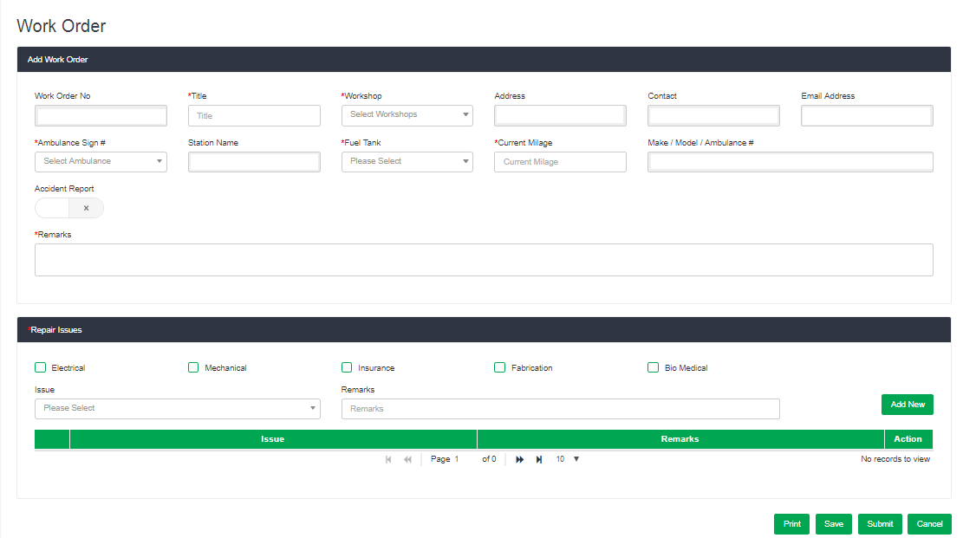

**Part – II: Submission**

